**Local information of CNS 2016 for website (Jeju, South Korea):**

**Conference Site**:

CNS 2016 will be held in **International Convention Center Jeju (ICC Jeju), South Korea**. ICC Jeju is located in Jungmun Tourist Complex in Jeju island, which is a volcanic island and a worldly renowned resort in South Korea. Main Meeting, Poster session, and Banquet will be held on the 3rd floor in ICC Jeju. The meeting rooms for the tutorials and workshop will be on 3rd and 4th floor.

URL: <http://www.iccjeju.co.kr/EN/Main>

Address: Jungmun Sightseeing Complex,

Seogwipo City, Jeju-do, South Korea

Phone: +82-64-735-1000

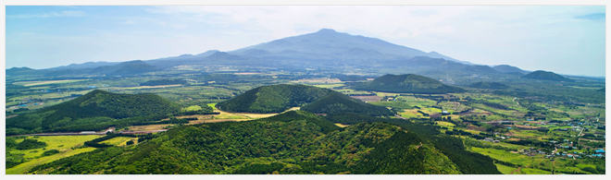

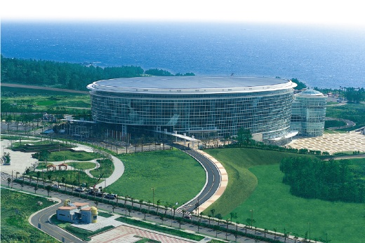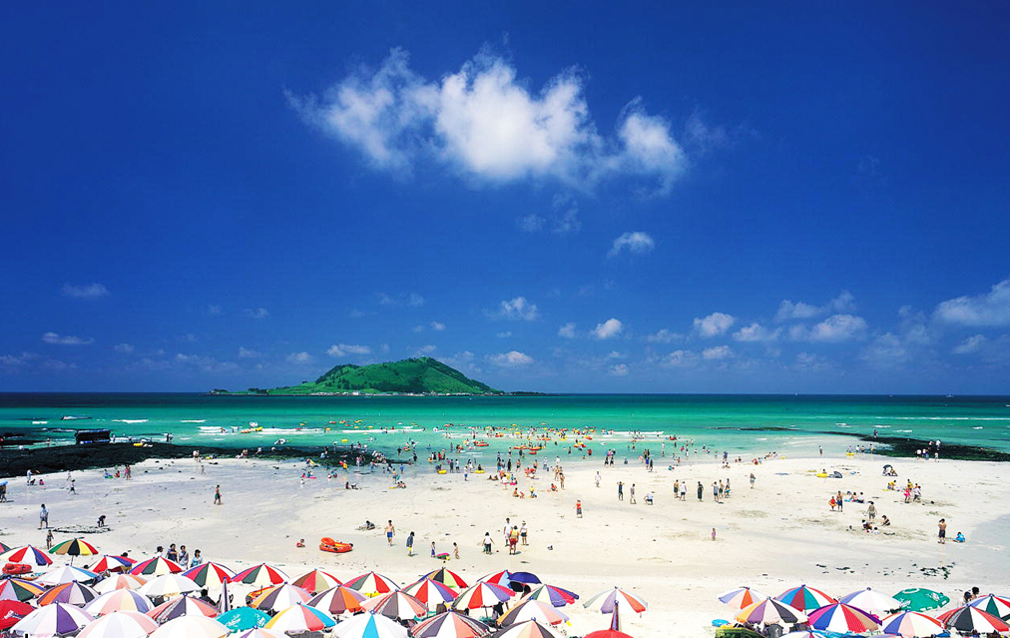

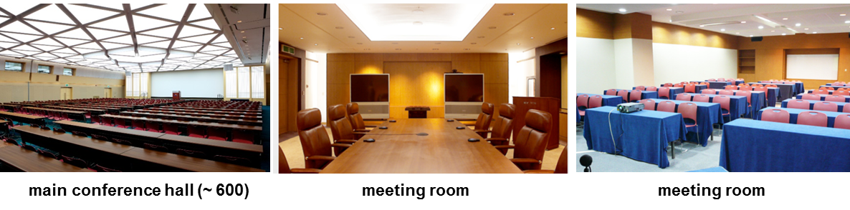

**Accommodations:**

Jeju, a world-class tourist destination, boasts the refinement in accommodations, and a variety of ranges from top-scale luxury hotels to affordable alternatives. There are about 1,740 hotel rooms and 1,719 pension (apartment-style privately owned condominium) rooms available within 20 km radius from ICC JEJU.

There are four special first-class hotels within the Jungmun Resort Complex, namely Shilla Hotel, Lotte Hotel, Hyatt Regency Hotel, and The Suites Hotel, and also abundant accommodation facilities such as family hotels, condominiums, and pensions (for more info: http://www.iccjeju.co.kr/EN/AboutJeju/Accommondation).

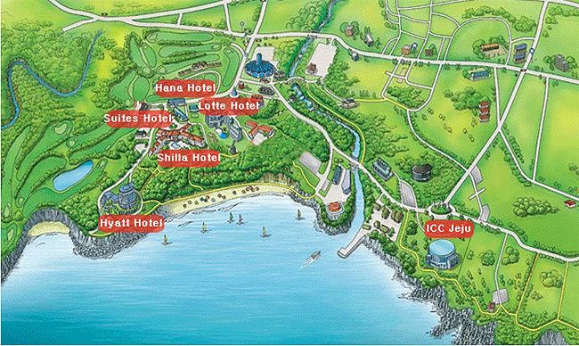

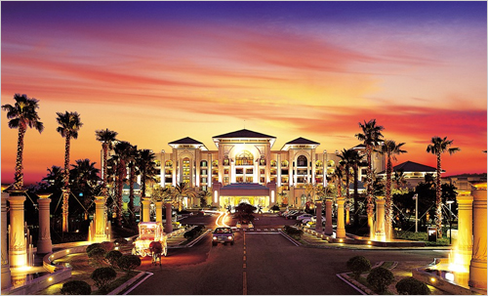

**High-range hotels**

* Lotte Hotel, Jeju

-Website: (<http://www.lottehoteljeju.com/kr/>)

-Price range: ~$250

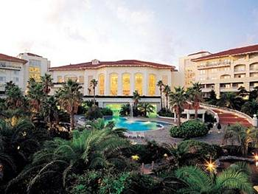



* The Jeju Shilla Hotel

-Website: (<http://www.shilla.net/jeju/index.do>)

-Price range: ~$250

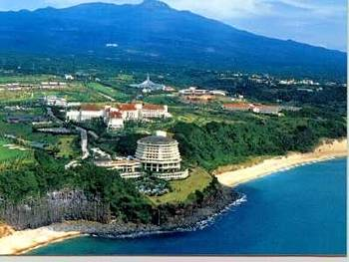

* Hyatt Regency Hotel

-Website: (<http://jeju.regency.hyatt.kr/ko/hotel/home.html>)

-Price range: ~$250

* The Seaes Hotel

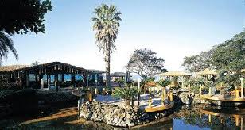

-Website: (<http://www.seaes.co.kr/eng/subpage.php?p=m82_eng>)

-Price range: ~$250

**Midrange hotels**

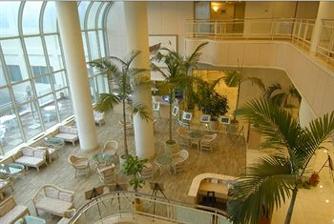

* Jeju Hana Hotel

-Website: (<http://www.hotelhana.co.kr/html/eng/in_010.asp>)

-Price range: ~$150

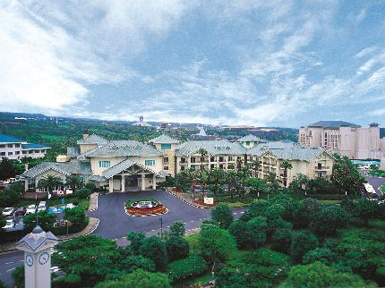

* The Suites Hotel, Jeju

-Website: ([http://jeju.suites.co.kr](http://jeju.suites.co.kr/))

-Price range: ~$150

* Lake Hills Resort, Jeju

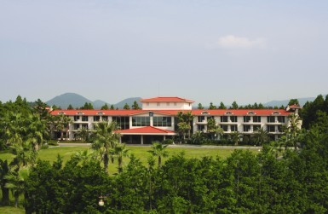

-Website: (<http://lakehills.co.kr/network/tel_jeju/jeju_main.html> )

-Price range: ~$150

**Student Accommodation <Low Budget Rooms>**

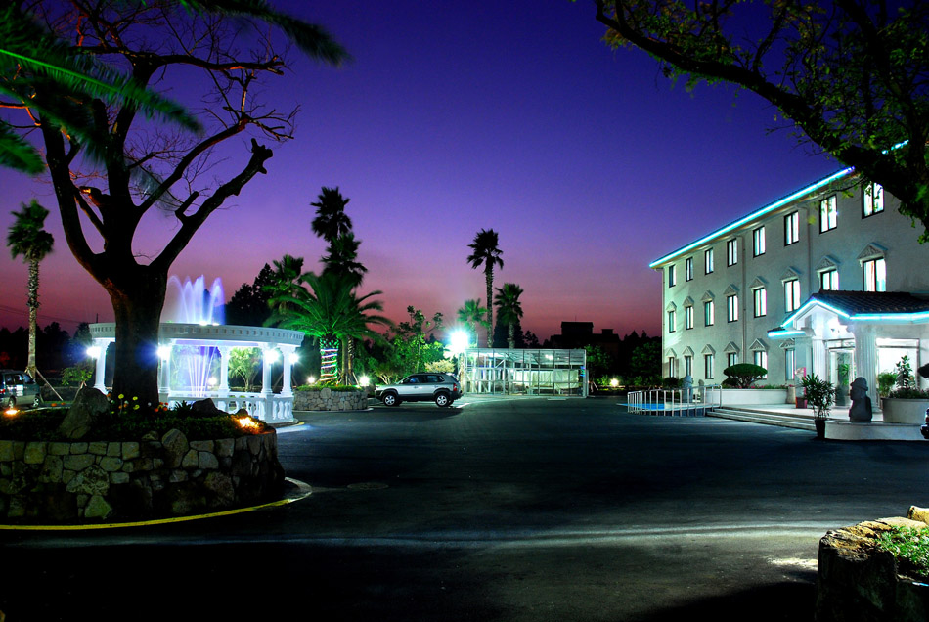

* Jeju Poonglim Resort

-Website: (<http://www.poonglimresort.co.kr/resort_jeju/jeju.asp>)

-Price range: ~$100

* Jeju Jungmoon Resort

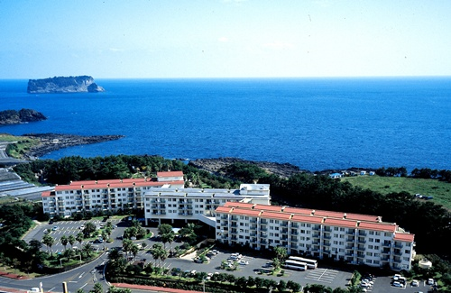

-Website: (<http://www.jungmunresort.kr/>)

-Price range: ~$100

**Transportation**

1. **Direct International Flights to Jeju island**

The most convenient way to travel to Jeju Island is by airplane. The flights link it with China, Japan, Taiwan and all major Korean cities are within one-hour flight. Jeju International Airport is conveniently located at the center of East Asia and is easily accessible from China, Japan, and Southeast Asia. The airport currently services 16 direct international flights and 13 domestic flights.

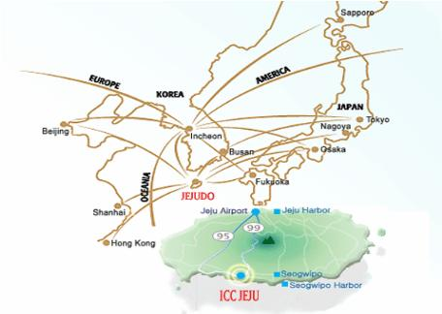

#### Transfer via Major Hub Airports

Visitors from countries without direct flights may easily travel to Jeju through major airports such as those in Tokyo, Osaka, Beijing, and Shanghai.

#### 3.Transfer via Incheon International Airport, Korea

Incheon International Airport is the gateway to Korea. It was ranked the 9th highest international passenger traffic with 79 airlines connecting to 182 destination cities.

* Passengers can either transfer to a direct flight to Jeju from Incheon, or move to Gimpo Airport and transfer to a domestic flight from there. It is a one-hour-flight from Incheon or Gimpo to Jeju.  
  To get to Gimpo Airport from Incheon, visitors can take a shuttle bus or high-speed rail. It takes approximately 30 minutes, and shuttle buses run every 5 minutes.

#### Airport

#### 4.Transfer via Gimhae International Airport, Korea

You can access Gimhae Int’l Airport by international flights form China (Shanghai), Japan (Tokyo, Fukuoka, Nagoya and Osaka), Russia, Taiwan, Thailand, The Philippines and Vietnam. The domestic flights from Gimhae Int’l Airport, which is the second largest international airport in Korea, to Jeju Int’l Airport run between 08:00 to 22:00 at roughly 15 minutes intervals. 40 domestic flights are in service daily on average as of December 2013.

Visa-Free Entry

* Visa-free Entry to Jeju: 180 Countries.  
  (Only 11 countries are required to apply for a visa: Afghanistan, Cuba, Ghana, Iran, Iraq, Libya, Nigeria, Macedonia, Palestine, Sudan, and Syria)
* Duration of stay: Up to 30 days
* Conditions of entry:   - Those that arrive directly into Jeju island by flights or ships.  
  * A Chinese tourist group arriving at the Incheon International Airport, who intends to travel to Seoul and Gyeongggi Province within 12 or 24 hours and then go to the Jeju island by transferring to the domestic flight. (Domestic connecting flight) - (Hereinafter referred to as 'group transit passenger to Jeju)  
  - For a group transit passenger to Jeju, a person must join a tour program of Korean travel agents that serve Chinese tourists groups only and that are designated by the Ministry of Culture, Sports, and Tourism, and the Chinese travel agents in charge of a group visa application at the Korean embassy or Consulate General in China. Also, a group transit passenger must hold a domestic airline ticket to the Jeju Island in which a flight departs within 12 or 24 hours (Source: Korean Immigration Office, [www.hikorea.go.kr](http://www.hikorea.go.kr/))

**From Jeju International Airport to ICC Jeju (and hotels)**

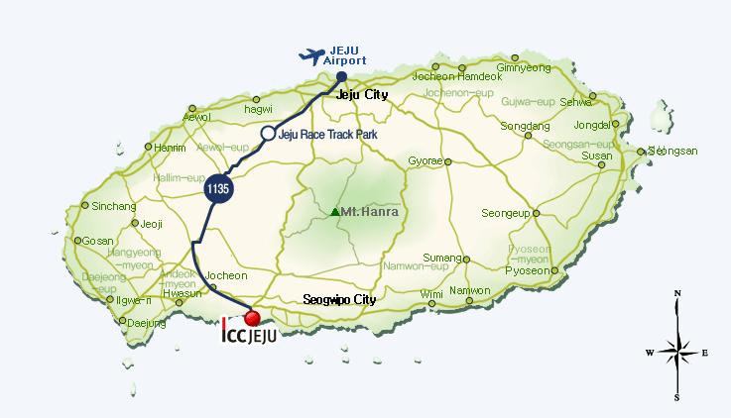

**Take an Airport Limousine Bus from Jeju Int'l Airport to ICC Jeju and conference hotels.** The limousine buses [Bus No. 600] run between 06:20 to 22:00 at roughly 15 minutes intervals, and the cost is KRW4,000 (about $3.5). It takes about 50~60 minutes.

**Taxi guide (Jungmun - Jeju International Airport)** 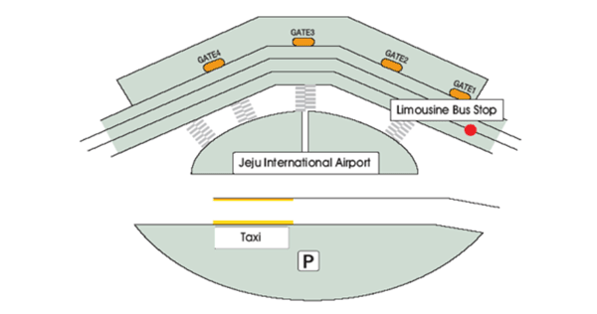

* Since the taxi fare is fixed, please confirm the distance before taking a taxi. Fare (Korean won) : About 30,000 won (Maximum $ 30); Distance: 40km; Duration: 40-45 minutes.
* Advanced reservation is recommended if you plan to rent a car. Upon arrival, you can sign up for rental cars at the rent-a-car desk nearby airport exit.

**Weather and tourist attractions**

**Weather**

Jeju island has a mild oceanic climate throughout the year with the smallest annual temperature range in South Korea. The temperature for the hottest summer months (in July) averages no more than 33.0 ℃ in and no less than -2.7 ℃ for winter. During the meeting in early July, the lowest temperature ranges from 21-23 ℃ and the hottest temperature ranges between 26-28 ℃ . (<http://www.iccjeju.co.kr/EN/AboutJeju/Info>)

**Tourist Spots**

With its natural beauty and unique island culture, Jeju provides with hundreds of tour options including pristine seas and fantastic rock cliffs, horses grazing on wide green meadows, and a variety of specialty museums. The island itself is an extinct volcano with its peak jutting skyward at the center and a broad, gentle littoral all the way around showing a very unique geographical condition. There are bountiful forests and ravines, fantastic rock formations and volcanic craters, and caves and grasslands that together paint a natural scene of breathtaking beauty. Sparkling seas and tiny islets surround Jeju, with rocks scattering amidst sandy beaches to create a magnificent view everywhere you look. Hallasan Mountain rises in the center of Jeju to 1950m above sea level. The rest of the island slopes down from its summit and is covered with dark gray volcanic rocks and volcanic ash soil. Relatively isolated from the rest of the world, the island’s nature has been well preserved in its prehistoric state. (<http://english.jeju.go.kr/index.php/contents/AboutJeju/intro/intro>)

**Leisure**

The island also offers a variety of leisure activities; snorkelling, scuba diving, kayaking, yachting, windsurfing hiking, golfing, fishing, horseback riding and paragliding, are available at numerous places throughout the island. Near Jungmun Resort Complex, where ICC Jeju is located, there are a variety of sight-seeing opportunities such as; the public 18-hole Jungmun Golf Course (about a 5-minute-ride), Yeomiji Botanical Garden (the largest indoor botanical garden in Asia), the Teddy Bear Museum, the Africa Museum, the Sound Island Museum, and Pacific Land. Scenic natural wonders include: Jungmun Beach, Cheonjeyeon Waterfall (according to the legend, seven nymphs guarding the heavenly emperor descended at night to bathe at night), and Jusangjeolli (natural stone pillars built up along the coast which are formed by magma piercing through cracks of the surface-rock. (<http://www.iccjeju.co.kr/EN/AboutJeju/TourAndLeisure>)

**8.** **Social Activities:**

Welcome reception: The welcome reception will be provided in the evening of the first day of the conference where buffet and drinks are prepared at the convention center. Attendees can enjoy social interactions with other participants during the reception.

Banquet: On the fourth day of the conference, we will prepare the banquet in the evening at the convention center. Dinner and wine will be served to the attendees who registered with the option of banquet included. Attendees can also purchase the banquet tickets for their companion when they pre-registered.

The banquet ticket will cost $30 per person. In the first part of the banquet, the organizing committee will prepare a welcome ceremony. In the second part, there will be a celebration event with the performance of Korean traditional music and arts.

Social night out: In the evening of the third day of the conference, a social party will be prepared at the local bar where attendees can enjoy drinks and food with social interactions. We will block several hours of the bar to host attendees. Attendees can purchase their own tickets for food and drinks on site.

Outdoor activity: We are planning to organize the Marina and Yacht tour nearby the convention center which attendees can register with an additional payment (about $50/person). In this tour, attendees can enjoy as a group food and wine, sightseeing of nearby islands and fishing. The tour will run everyday during the conference based on reservation.